Hello,

Thank you for purchasing our backuping software. This short guide will show you how to install our software and how to deploy it to clients.

HOW TO SET UP:

1. Download our KoFrMa Backup Solution install package (DatabaseCreator, RestAPI, Daemon, LocalDaemonConfig and AdminAppAngular) from link included in your email and extract it.

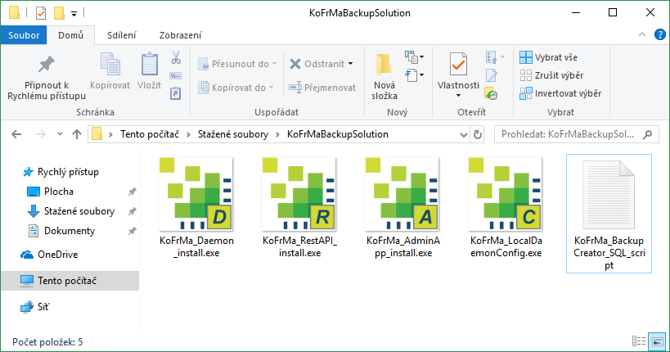

1. Create database by running the SQL query from KoFrMa DatabaseCreator on your MySQL server.

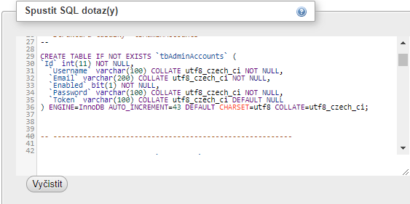

1. Install and start KoFrMa RestAPI by following the install instructions on your server where it will be permanently running and accessible by all devices 24/7.
2. Install and run KoFrMa AdminApp on your server (can be different machine than the one hosting RestAPI or MySQL).
3. Login to the KoFrMa AdminApp with default credentials that were given to you with the license when you ordered it.

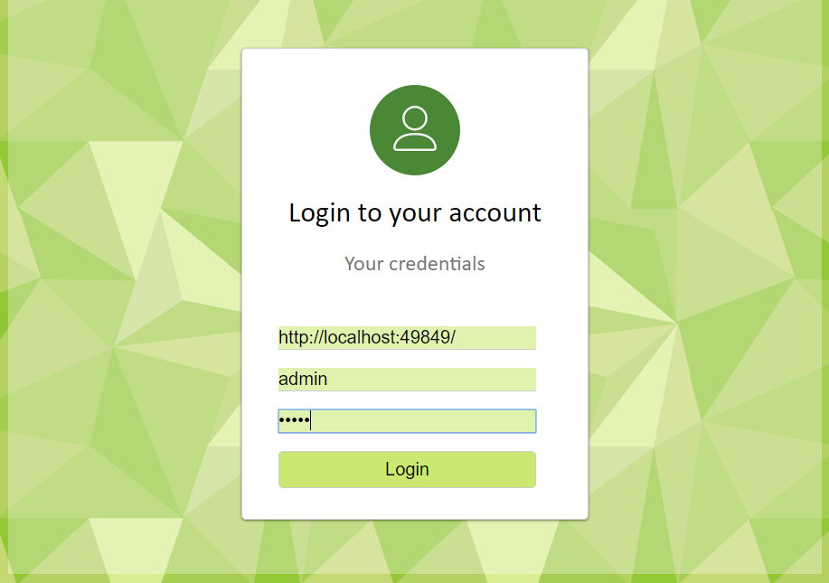

1. Install the KoFrMa Daemon on the computer(s) that you want to backup, by running KoFrMa Daemon Installer and following instruction on-screen.

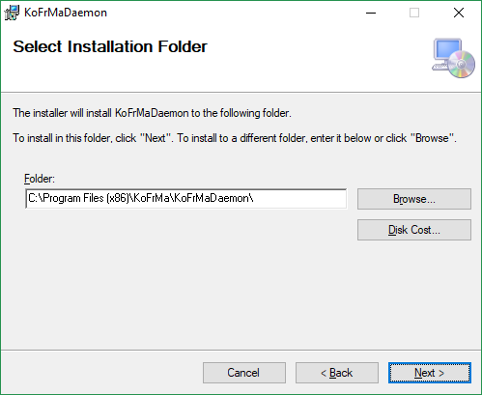

1. Run KoFrMa LocalDaemonConfig on the computer where the daemon has been installed and enter URL of the RestAPI server and password that will authorize the daemon.

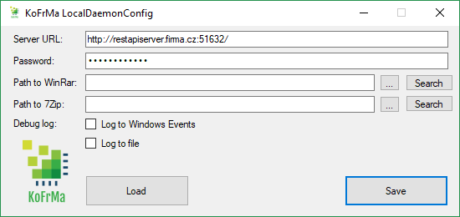

1. If you want to use .rar and .7z proprietary formats as destination for your backups, simply press the search button if you have them installed in most used locations or enter them manually.



1. Decide if you want to log actions that daemon does on client computer, either by writing to text file in given location or writing to Windows Event Log.



1. Save changes and restart your computer

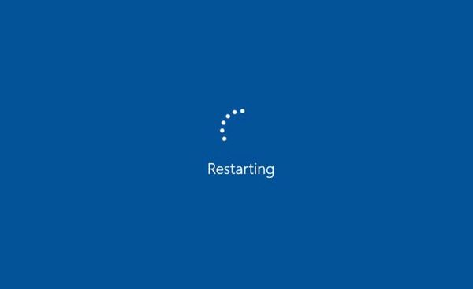

1. You should now see the daemon listed in AdminApp and start adding tasks to it! (If you want to know how to add tasks, see our Add Task tutorial) If you want to install the daemon on multiple computers, repeat actions 8-12.

Thank you for using KoFrMa Backup Solution.

System requirements:

Windows 7 Service Pack 1 or higher

1 GHz processor

2 GB RAM minimum, 4GB recommended

5MB drive space minimum, 40GB recommended

Network connection